**axis_signal_gen_v6**

Introduction

This ip receives waveform info (explained below) from tproc, and play pulse accordingly. This ip can also store envelope data.

Specs

To know how to program values for the following quantities from python, see the section *qick python library*.

* Phase[1]: 0 to 360 degree, resolution is 32-bits (step 360/232).
* Gain: 16-bits integer (-32768~32767). (TODO: include GFP table)
* DDS frequency (fs is sampling rate of DAC, and fdds = fs)[2]: from 0 to fdds, resolution is 32-bits (step fdds/232­­­).

(Note: DAC’s actual output frequency is DDS frequencies, together with their images (see *Sampling & re-construction* section).)

* Nyquist zone: 1 or 2.
* Available waveform style: const (square wave), arb (completely arbitrary). Some build-in arb styles are, flat_top (gaussian square), gauss. For details, see the section *qick python library*.
* Waveform length:
  + const: no limit.
  + arb: can vary. Envelope memory size for particular bitstream can be obtained from python:

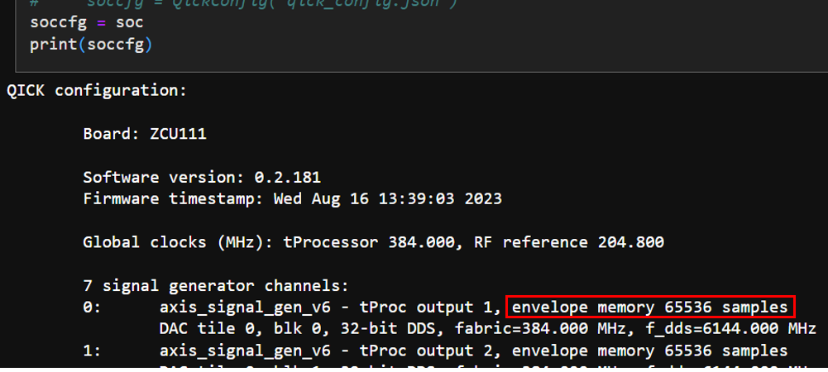

Envelope memory size can be modified by changing the N below. The envelope memory size is equal to 2N * N_Dds.

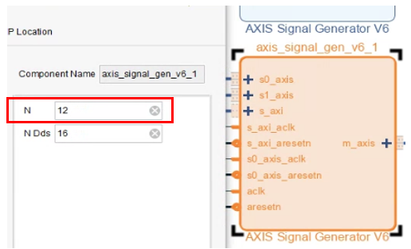

How to get started using it (zcu216, vivado2020.2)

The demo codes are here:

<https://github.com/Ri-chard-Wu/thesis/blob/master/codes/fullspeed-ro-sg-demo-216/fullspeed-ro-sg-demo-216.ipynb>

The wiring is simple loopback from a DAC to a ADC. We will first play a pulse of style const with fullspeed sg, then read it with fullspeed ro.

The Phase, Gain, DDS frequency, waveform style, and waveform length mentioned in *Spec* are used this way:

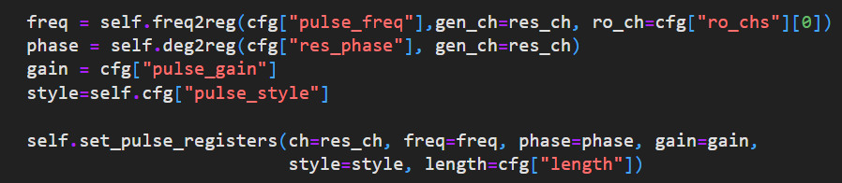

and for Nyquist zone (nqz):



Demo of other waveform styles are available on QICK’s official github at:

<https://github.com/openquantumhardware/qick/blob/fb4a08fc544345af344e129b6d7c1bd98cf914f3/qick_demos/00_Send_receive_pulse.ipynb>

How it work

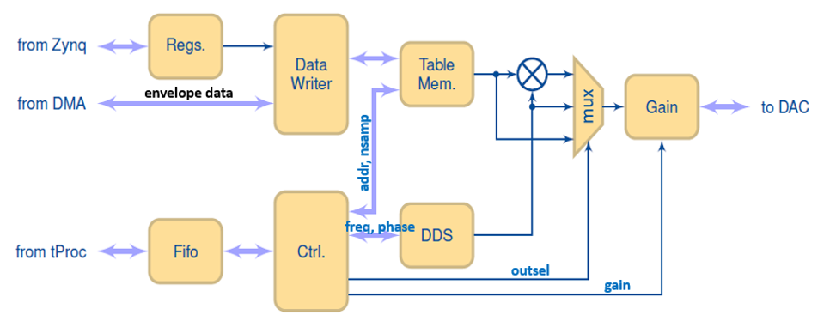

* Before writing envelope into *Table Mem*, the qick’s python lib will first write starting address and length of the envelope data into *Regs*, then begin to transfer envelope through “from DMA” into *Table Mem*.
* Waveform info is sent in from “from tProc” and queued in *Fifo*. The *Ctrl* will take out and process the queued waveform info one by one from *Fifo*.
* The waveform info contains

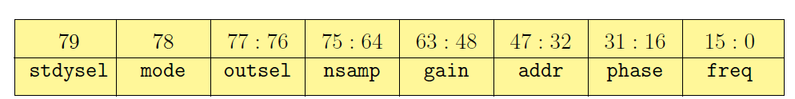

* + For *DDS* block: phases, frequency.
  + For *Table Mem*: starting address and length to readout the envelope to be multiplied with DDS’s output (sinusoidal).
* The *DDS* block contains 16 DDS’s. The DAC’s sampling rate fs need to be equal to faclk * 16.

how to include it in firmware (zcu216, vivado2020.2)

IP core settings (double click on the ip):



RFDC (Zynq Ultrascale+ RF Data Converter) DAC settings:

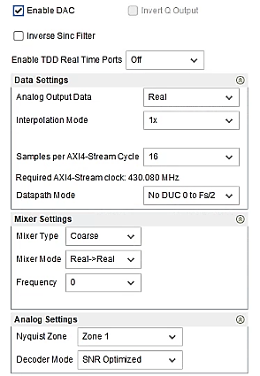

RFDC DAC tile clocking settings:

* For details about the fields see the section *rfdc settings*.
* For demo purposes, just select *Clock Source* to be the tile itself, and select *Distribution Clock* to be *off*. For details, see the section *rfdc settings*.



1. relevant qick functions: QickConfig::deg2reg().
2. relevant qick functions: QickConfig::freq2reg(), QickConfig::freq2int().